**(JASS**

**SYSTEM ARCHITECTURE -SYSTEM SEQUENCE DIAGRAM**

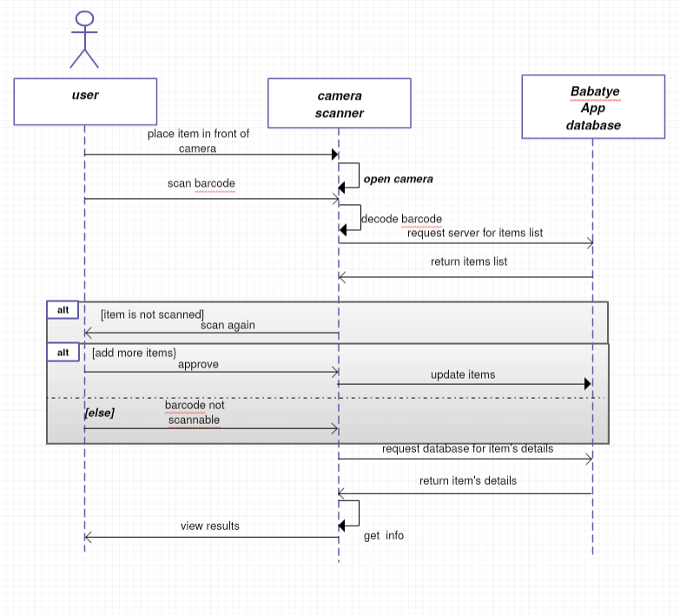

**BREIF EXPLANATION**

*As a user, when I will place the item in front of the camera , camera will scan the item barcode*

*Then the user’s mobile app will send request to the Babatpe server for the data repository and the system will return the items list*

*Once, the scanned ites are approved , the items will be updatedin the database*

*Then user;s app will request database for items datails , ans database will return thw scanned items datails*

*Then , the app interface will view results*

***Alternative***

*either the item is not scanned , the system will ask to rescan it or the barcode is not scannable*